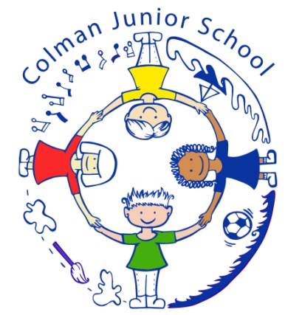

Mrs Julie Sandford South Park Avenue
Headteacher Norwich NR4 7AU

An evening with Paul Whittaker OBE on Monday October 1st 7-9pm
This is an open invitation to:
- parents of children at Colman Junior School
- other parents in the community
- any school staff
- anyone involved in music groups or choirs
- anyone else interested in Deaf awareness/singing/signed song
Colman Junior School are delighted to announce that Paul Whittaker is returning to our school for another day of singing and signing with our children.
The evening before, Paul has offered to come to talk to the adults! It is a wonderful opportunity to see how signing complements singing and makes music accessible for all children.
Paul is an inspirational speaker, musician, performer and workshop leader who is profoundly deaf. For 30 years, he has been entertaining and educating people about music and Deafness across the UK and beyond, at schools and colleges, conferences and theatres, courses and training events. The session will give you a taste of music, signed song, Deaf awareness and laughter!
At Colman, we are particularly proud of the tradition that we have of singing and signing. In the past, we have taken our signing choirs to the Norfolk County Music Festival and perform every year at the Summer Deaf Festival at the Forum. Paul has been helping us develop these skills so that we sing to the highest level and translate the songs into BSL so that we are signing the true meaning. It is a fascinating process.
BSL is now part of the curriculum for our Year 3 children because we recognise and celebrate that BSL is a language of our community.
To enjoy the evening, you do not need to have any experience at all of singing in a choir or of signing.
If you are interested in attending, then we would be very grateful if you could let us know so that we, and Paul, can prepare for the evening as best we can.
Thank you in advance and we look forward to seeing you. If you have any further questions, then feel free to e-mail Fiona or Kirsty and we will try to help.
Yours faithfully,
Fiona Wallis Kirsty Denton
Teacher of the Deaf Music Teacher
You can give the reply slip to the office at Colman Junior School or send an e-mail to FWallis@colmanjunior.norfolk.sch.uk or KDenton@colmanjunior.norfolk.sch.uk
....................................................................................................................
Reply slip to Fiona Wallis or Kirsty Denton please
I would like to attend the evening with Paul Whittaker on Monday October 1st 7-9pm at Colman Junior School.
Name: __________________________________________________
Contact number (in case the details of the evening change) ________________________________________________________
Reason for interest: _______________________________________
_________________________________________________________

