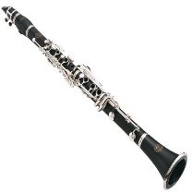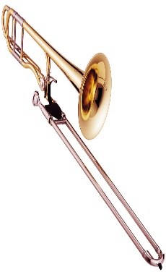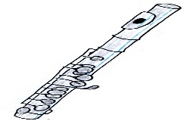
This Photo by Unknown Author is licensed under CC BY-ND

Are you learning to play a brass or woodwind instrument? Then why not join:
‘WINDBLOWERS’
the new, fun, free ensemble
Each Monday in term-time
Starting Monday 13 January 2020
3.45 – 4.30pm
At Fakenham Academy and Sixth Form
Field Lane, Fakenham, NR21 9QT

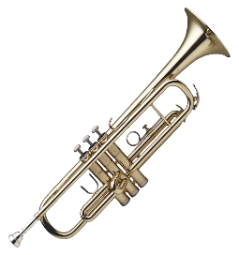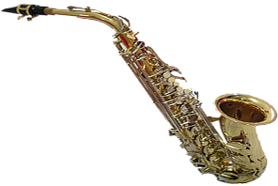

Get your Application Form and apply now!
Application Form for ‘WINDBLOWERS’

To take part and guarantee your place, fill in this form and return to Mr I Willis at the Academy by Friday 6 December 2019.

Name of Student: ……………………………………………………………….
Instrument played: ……………………………………………………………….
Current School and Year: ……………………………………………………………….
Length of time playing: ……………………………………………………………….
Has the student taken any music exams on this instrument, if so, what grade? ……………………………………………………………….
Name of Parent/Carer: ……………………………………………………………….
Contact Number of Parent/Carer (emergency use only): …………………..
I understand that it will be my responsibility to bring my child from their primary school to the Academy and to ensure safe collection from the Academy each week.
Signature of Parent/Carer: ……………………………………………………………….

Please note that this activity is provided free of charge with support from Fakenham Academy and Sixth Form and Norfolk County Music Service.

