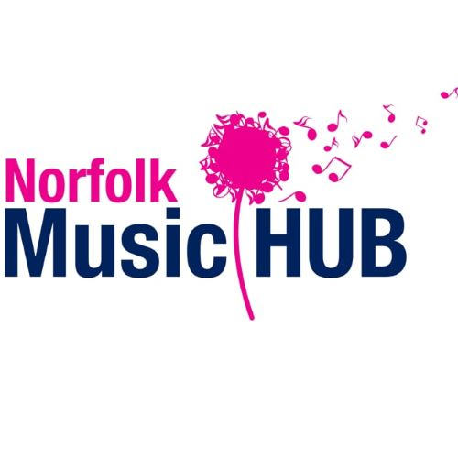
Norfolk Music Service/Hub Music Guidelines for Parents and Students for digital delivery of summer workshops 2020.

Norfolk Music Hub (NMH) will be delivering workshops remotely and online over the summer holidays

This policy covers the safeguarding and operational requirements for situations where learning for a student is provided outside of either a school/education and delivered on an online platform. We have this policy to ensure that the safeguarding of all taking part in teaching and learning is managed to the highest standard and that the processes that should be followed are clear.

Safeguarding is our highest priority which we take very seriously, and any concerns are followed up immediately to ensure a safe and secure environment for learning.
Designated Safeguarding Lead: Alison Bell: Email: alison.bell@educatorsolutions.org.uk
Tel: 07428655322

For the safety and security of students, parents/carers, and staff, the following procedures must be adhered to. Parents/Carers will be required to sign a form to give consent for online tuition to commence for their child(ren).

Contact details for Norfolk Music Services are:
Telephone: 01603 303351 (General Office)
Email: musicservice@educatorsolutions.org.uk

DELIVERY OF WORKSHOPS
- All workshops are timetabled and will run as advertised over the summer holidays.
- Parents/carers of students who have signed up to participate in one of the workshops will be contacted directly by a member of Norfolk Music Service via the email provided. This will include instructions as to how to join this workshop.
- Workshops will be conducted through Zoom and staff will use Norfolk County Council email addresses/accounts to supply details of the workshop.
- Parents/carers are asked to login for their child.
- Accepting the invitation to a webcam workshop will act as confirmation that you have read this and give permission to proceed.

SAFEGUARDING
- Norfolk Music Service / Education Hub safeguarding policies and code of conduct remain in place for both face-to-face and online music delivery and are available through the policy page of our website.
- Students and Tutors/Workshop Leaders are required to be dressed appropriately for remote learning.
Attire which would ordinarily be worn in school on a non-uniform day is essential;
clothing, worn by a student or a Tutor/ Workshop Leader, which does not meet this expectation is not acceptable and lessons should be stopped immediately and reported to the Norfolk Music Service Safeguarding officer.
- NMS must always confirm at the start of each workshop that an adult is in close proximity to the student and should be present at the start of the workshop.
- As with all school-based communications, the content and language of messages and conversations must at all times be professional by all parties concerned, including family members.
- Any issue that arises as part of the provision of these mechanisms used for workshop will be dealt with promptly by an appropriate manager in the service.
- The Designated Safeguarding Lead may suspend the approval for providing sessions if necessary while an issue is being investigated or following an investigation.
- Workshop leaders and Workshop participants:
  - must not pass their personal mobile number on.
  - must not audio or video record, or stream, the lessons film or share any content over social media.
  - must not friend or follow pupils or staff on their personal social media accounts.
- The professional boundaries should remain clear at all times and therefore Workshop leaders must not accept any offers to do online teaching over webcam / video chats, as this practice increases the risk to student and Workshop leader and professional boundaries must be maintained in all circumstances.

RIGHTS AND PERMISSIONS
- Online tuition is carried out under the same Terms and Conditions as on our website at https://www.norfolkmusichub.org.uk/site/?s=policies
- Norfolk Music Services / Norfolk County Council has a risk assessment for this work, based on this policy, as well as on health and safety, and safeguarding policies.
- Teaching is conducted through Zoom.
  - Zoom’s Privacy Policy is available here: https://zoom.us/privacy

SUITABLE ENVIRONMENT

- Students and Workshop Leaders must be physically located in safe working spaces, appropriate for online workshop; a lounge or study is appropriate, a bedroom or bathroom is not.
- Students should be in a room with or near an adult so that the adult can hear and see the workshop taking place and is the responsibility of the parent/carer to ensure this is happening.
- Workshop Leaders/ Tutors should be in a room where others cannot see or listen in, if this is not possible, then headphones must be worn, and screens angled away towards a wall and away from any other people.
- Recommended virtual backgrounds are available on remote platform (which blocks out any surroundings), as is the option to blur the background.

OBLIGATIONS
Norfolk Music Service management will:
- Have a risk assessment that is reviewed and updated by managers for staff carrying out delivery of these activities
- Have clear procedures for managing queries or concerns for students, parents/carers, and tutors, during and after sessions, including contact details for relevant managers.
- Provide students, parents and carers information in advance about the software to be used for live video sessions and how and by whom it can be accessed.
- Discuss the process with parents/carers if requested, before any live video lessons take place, to identify any concerns and provide additional support where needed.

Parents/Carers (and students aged over 18) will:
- Follow the guidance as detailed in this document
- Provide a suitable device for live video sessions with microphone, headphones and camera, and will ensure that the device is switched on and working in time for the start of the session, with power points in a good condition and not overloaded. (Bluetooth headphones and built-in camera and microphone are recommended.)
- Provide internet connection of sufficient data capacity and bandwidth.
- Ensure that the device to be used for live video sessions has a suitable adult email account for accepting a link to the live video session.
- Ensure that students, they themselves and any other adults or children visible by the tutor are dressed appropriately for being seen in a public context during home visits and live video workshops.
- Ensure that other children and young people under the age of 18 do not come into sight of the camera during live workshops.
- Not record the screen of the device being used for a live video session.
- Not request the Workshop Leaders/Tutors email address or mobile number.
- Agree to not share any passwords.
- Not share or redistribute any content.
- Be present at the start of the workshop.
- Be available for a conversation with the member of staff if required during that time.
- Be sensitive in ensuring that there are not interruptions to the work being carried out and conversations at the end of the session do not delay our staff in departing for their next appointment.
- Ensure they attend with their child if they are under 18 years old or provide a suitable adult notified in advance by the account holder to accompany the child.
- Remain in the workshop if requested by the member of staff.
- Accept that a session can only be provided if the conditions of the policy are met and that a charge for time may still be liable should it not be possible to provide the session if the staff member deems that they would be unable to comply with the policy.

