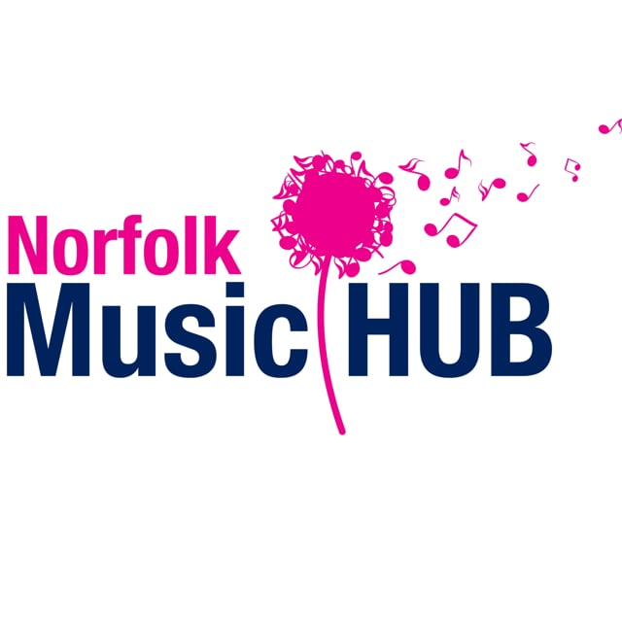

Instructions for October Half Term Workshop leaders

Microsoft Teams Security Settings

In order to protect pupils and staff when teaching the following settings MUST BE USED
- All workshops password protected.
- All workshops will be delivered using a paid license (no free meetings will be hosted).
- All workshops will use a waiting area where NMS staff will allow pupils into the workshop.
- Only pupils on the teachers register will be entered at that point.
- All pupils will enter the workshop with their microphones muted.
- If accessing by app the most recent version must be used.
All settings will adhere to the Cabinet Office and Government Digital Service settings to ensure Microsoft teams is as secure as possible.

Safeguarding

- All the rules for safe, professional behaviour that apply in a school workshop.
- Workshop leaders should always be dressed professionally
- All workshops invitations must go to parents/carers with the ‘Guide for Parents’ attached to the first invitation. The parent/carer should then log in for the child. This will be administered by Norfolk Music Service staff.
- If parents choose to send the link to a child so that the child can login, they are taking responsibility for doing this.
- Parents can of course remain in the room if they want to. Other children should be not be present i.e. visible in the workshop. It may be that other children are out of sight in the same room and that is acceptable, providing they are not disturbing the workshop.
- The student cannot join the workshop until it is started by a member of the Norfolk Music Service staff, which means this workshop is not controlled by the students.
- Parents/carers will have received instructions about suitable space in their house for these workshops to take place. This should not be a bedroom (although bedroom acceptable if they have arranged camera so that room is neutral). If a member of NMS staff are not comfortable with the room set up then the students can be removed from the workshop and the parents will be emailed by either Krista Ribbons or Alison Bell.
- NMS are the host of the ‘meeting’ and can mute participants and can end the workshop at any time. It will be ended immediately if anything happens that is deemed inappropriate of feels uncomfortable. All participants parents/carers will then be contacted via email.
- There will always be a member of SMT ‘on duty’. There will be an emergency protocol in place to ‘call over’ the on-duty member of staff: send a text message SOS and your name to the on-duty manager.
Krista Ribbons-07941083203
Alison Bell-07428655322
- There will always be an additional member of staff from NMS present during the workshops. This member of staff will be responsible for running the workshop and registering the attendees. This will either be Krista Ribbons or Amelia Rous Milligan

- Duty managers and Designated Safeguarding leads will be
Tuesday 27th October Krista Ribbons
Wednesday 28th October Krista Ribbons
Thursday 29th October Krista Ribbons

Lesson Preparation

- Select a suitable room where you will be undisturbed and external noise will not affect the lesson
- Check the background to ensure there are no posters, photos, personal information etc. and that your background looks professional. There are digital backgrounds which can be used if you prefer.
- Dress professionally. Don’t wear very bright colours and/or highly patterned items.
- Ensure there is no bright light source behind you.
- Have any materials and equipment ready before the lesson – shuffling paper can sound very loud over a computer audio

Workshop Delivery

- Students cannot join the workshop until a member of the NMS staff start it - keep to the schedule you have set (just as in normal teaching you don’t want children waiting for a long time).
- If you can’t hear your pupil, it is probably because their end is muted – use the chat message to tell them to turn it on at the bottom left of the screen - only use ‘chat’ when absolutely necessary.
- You will need to get used to being quiet whilst a pupil is speaking or playing as your audio will cut in when you do. Acknowledge through eye contact and gesture whilst they are doing things.
- As a group workshop, be aware that you can only hear one player at a time. You can select which one you want to hear by muting the other(s) if you want them to respond at the same time.
- Make sure that you end the lesson and when you’ve finished teaching that you exit Microsoft Teams so that no one else can use your login.

Should you require any other advice contact Alison Bell or Krista Ribbons

